

Final Project Proposal

**SUMMER 2023**

| **Project Title:** | **TechGadget Price Forecaster** |
| --- | --- |
| **Degree Program/ Title:** | **BSCS** |
| **Project Supervisor Name and Designation:** | **Dr. Faiza Nasim (Faculty)** |
| **Student Name(s), Registration No:** | 1. **Hammad Akhtar (18634)** 2. **Muhammad Salman (16557)** 3. **Jawwad Ahmed (19501)** |

| **PROJECT ABSTRACT** |
| --- |
| **Introduction:**  The Tech Gadget Price Predictor is an AI-powered tool that uses machine learning algorithms to predict the prices of tech gadgets. It analyzes historical pricing data, relevant features, and external factors to generate accurate price forecasts.  **Problem Statement:**  The prices of tech gadgets are constantly fluctuating, making it difficult for businesses and consumers to make informed decisions about pricing strategies, investments, and purchases. The Tech Gadget Price Predictor can help to address this problem by providing accurate price forecasts in real time.  **Objectives:**  The objectives of the Tech Gadget Price Predictor project are to:   * Develop a machine learning model that can accurately predict the prices of tech gadgets. * Collect and preprocess historical pricing data for a variety of tech gadgets. * Identify relevant features that can be used to predict the prices of tech gadgets. * Develop a user-friendly interface for the Tech Gadget Price Predictor.   **Expected Results:**  The Tech Gadget Price Predictor is expected to provide accurate price forecasts for a variety of tech gadgets. The project is also expected to identify the factors that most influence the prices of tech gadgets. This information can be used by businesses and consumers to make informed decisions about pricing strategies, investments, and purchases. |

**FLOW CHART:**

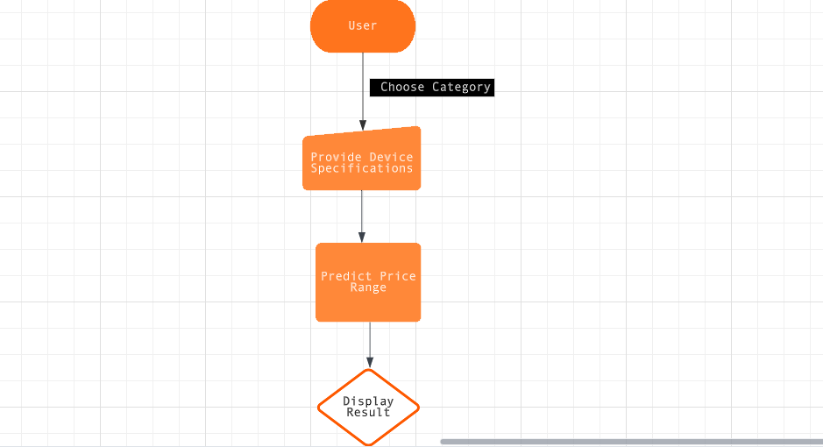

**DATASET INFORMATION:**

For our Tech Price Predictor project, we have sourced the dataset from [www.kaggle.com/](https://www.kaggle.com/), a renowned platform for open-source datasets and data science competitions. The dataset comprises historical pricing data for various tech products, including laptops, smartwatches, graphic cards, and This comprehensive dataset offers a wide range of information, such as product specifications, brand details, and timestamps of price changes. With this rich and diverse dataset, we can extract valuable insights and trends that will drive the accuracy of our predictive models. Kaggle.com provides a reliable and accessible resource for data scientists and AI enthusiasts, ensuring that our Tech Price Predictor project is built on high-quality data and aligns with industry standards. Leveraging the power of Kaggle's dataset and community support, we are confident that our Price Predictor will deliver robust predictions and empower businesses and consumers to make informed decisions in the dynamic tech market.

**METHODOLOGY:**

**LAPTOP**

Creating an AI-powered laptop price prediction model using 2020-2021 dataset, offering users personalized estimated prices by analyzing device specifications, facilitating informed purchasing choices.

**Link:**

<https://www.kaggle.com/code/danielbethell/laptop-prices-prediction>

Before EDA:

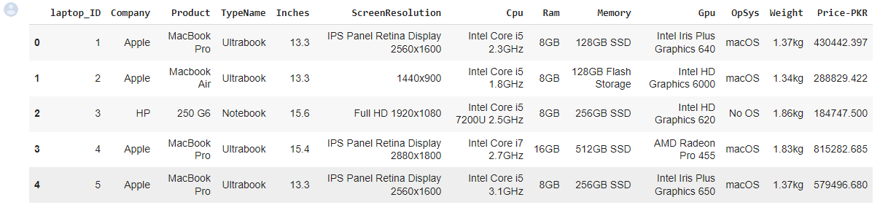

After EDA:

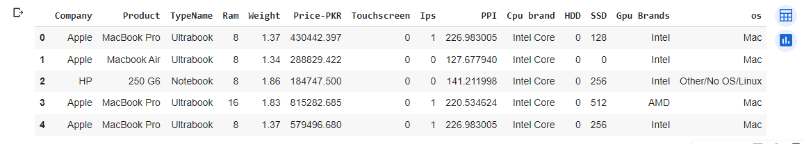

**SMARTWATCHES**

Crafting an AI-driven smartwatch price prediction solution leveraging a 6-month-old dataset, delivering users projected prices based on device specifications, enabling well-informed smart purchasing decisions.

**Link:**

<https://www.kaggle.com/datasets/rkiattisak/smart-watch-prices>

Before EDA:

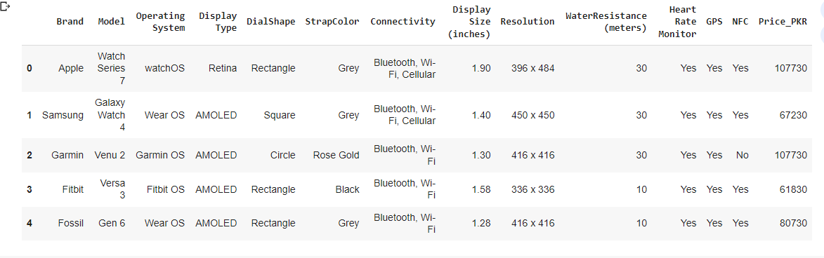

After EDA:

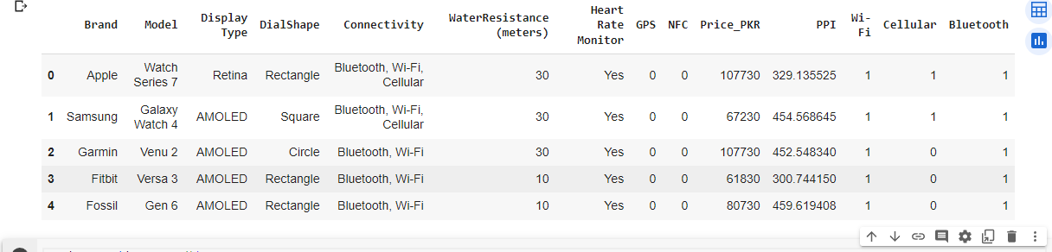

**GRAPHICS CARD**

Developing an AI-driven graphics card price prediction system utilizing data from October 2022 to March 2023, offering users anticipated prices derived from device specifications, empowering strategic purchasing choices in the dynamic market.

**Link:**

<https://github.com/docyx/pc-part-dataset/blob/main/data/json/video-card.json>

Before EDA & After EDA. Just dropped GPU ID

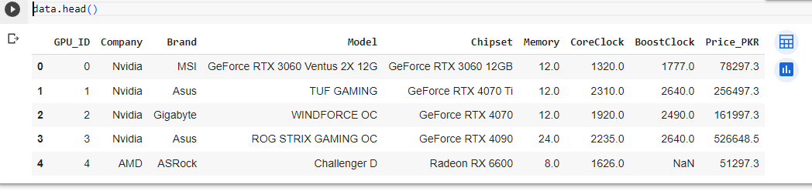

**LAPTOP EDA GRAPHS**

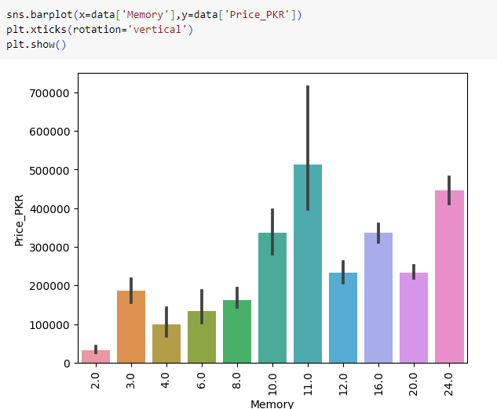

The above graph depicts that the price is influenced by the memory of Laptop.

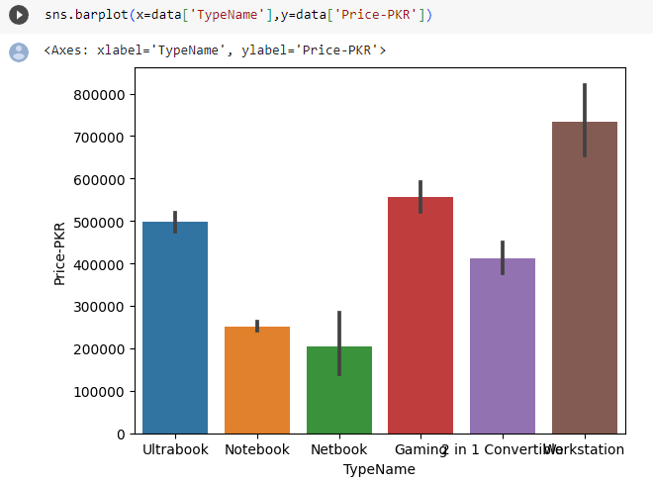

The graph above illustrates the price of laptops in Pakistani rupees (PKR) according to their type.

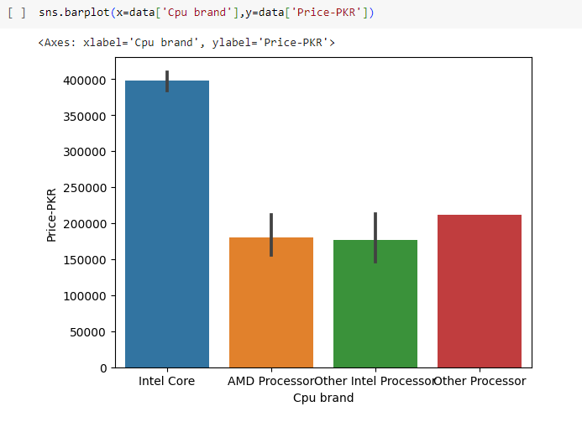

The above graph depicts that the price is highly influenced by the CPU of Laptop.

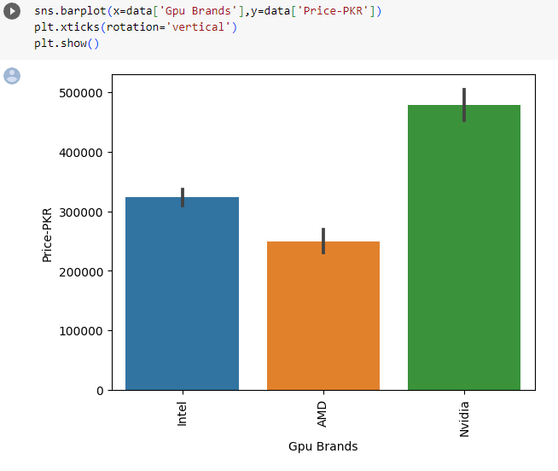

The given graph illustrates the price of laptop having integrated and dedicated Graphics Card.

**GRAPHICS CARD EDA GRAPHS**

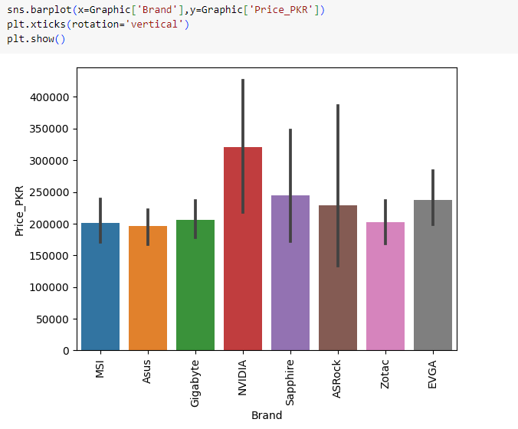

The above graph shows that the price depends on the brand of the Graphics Card.

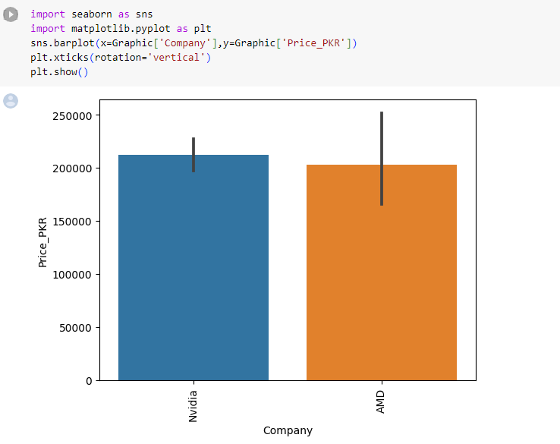

There are two main producers of Graphics Card chipset namely Nvidia and AMD. The above graph shows the price trend of both producers and depicts the influence of price based on company.

**SMARTWATCHES EDA GRAPHS**

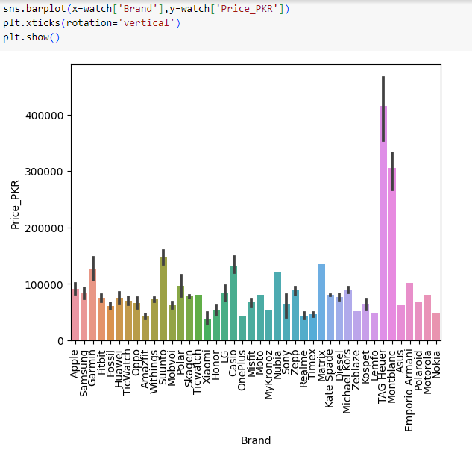

The graph observed above shows the price range targeting the brand of the smartwatches.

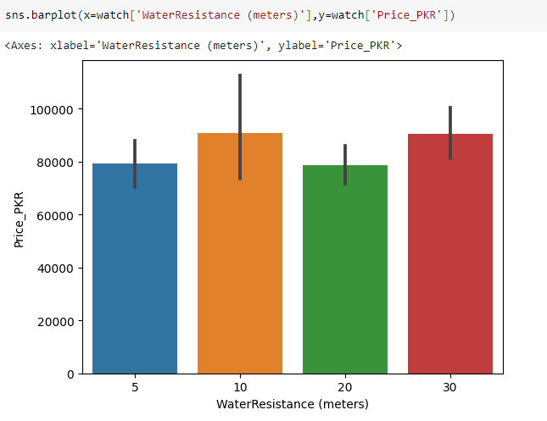

The above graph shows that our target label which is PRICE PKR is highly influenced by the feature of Water Resistance as the consumers usually buy smartwatches with that particular feature.

The prices calculated in the dataset are based on current Forex Rates. The actual datasets have different currencies we converted it accordingly

**CONCLUSION:**

In conclusion, our machine learning project successfully predicts laptop, graphics card, and smartwatch prices in PKR (PRICE_PKR) based on user specifications using Random Forest and Ridge Regression models. We curated a diverse dataset, conducted rigorous preprocessing, and engineered features for improved model performance. Our user-friendly Streamlit GUI enhances accessibility, aiding informed tech purchases. This project offers a valuable tool for consumers and retailers, improving the tech shopping experience in a dynamic market. Our adaptable models demonstrate the real-world application of machine learning, contributing to informed decision-making in the tech industry.

**FUTURE IMPLEMENTATION:**

* Additional Product Categories
* Price comparison between 2 devices of same type
* Mobile Application

**CONTACT US FOR ANY QUERY:**  
  
Name: Muhammad Salman

Email: [muhammad.16557@iqra.edu.pk](mailto:muhammad.16557@iqra.edu.pk)

Name: Hammad Akhtar

Email: [hammad.18634@iqra.edu.pk](mailto:hammad.18634@iqra.edu.pk)

Name: Jawwad Ahmed

Email: [jawwad.19051@iqra.edu.pk](mailto:jawwad.19051@iqra.edu.pk)